**Color Scheme & Typography:**

**Main Colors & Button Colors:**

**Main Color**:

RGB 245,41,135 #f06292 pink lighten-2

**Secondary Color**:

RGB 179,229,252 #b3e5fc light-blue lighten-4

**Tertiary Color:**

RGB 234,128,252 #ea80fc purple accent-1

**Positive / Submit**:

RGB 0,230,118 #00e676 green accent-3

**Negative / Cancel**:

RGB 244,67,54 #f44336 red

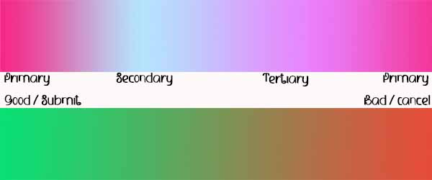

**Font Styles:**

